**Unveiling the Keys to Shopify App Success: A Data-Driven Analysis**

**By Camille Johnston**

1. **KPI**

1. **Line Chart**

1. **Scatterplot**

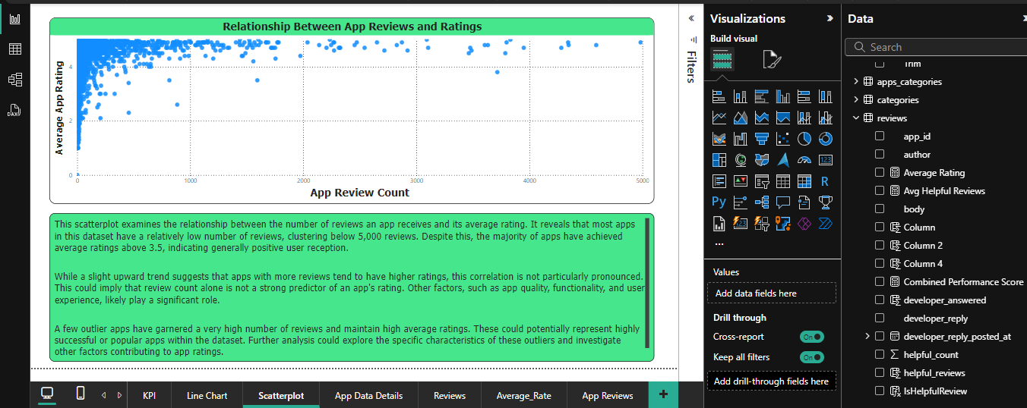

1. **Reviews**

1. **Average_Rate**

1. **App Reviews**

1. **All Tables (Many to One)**

